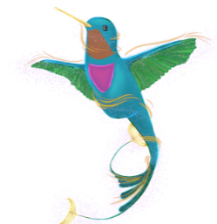**Hummingbird Needlepoint Services**

[**Carmstrong8721@gmail.com**](mailto:Carmstrong8721@gmail.com)

**301/483-8702**

**Finishing Form**

|  |  |
| --- | --- |
| **Name:** | |
| **Email:** | **Phone:** |
| **Address** | |
|  | |
| **Canvas Description:** | |
| **Fabric Color and Type Preferences:** | |
| **Lining Color and Type Preferences:** | |
| **Cording Color and Type Preferences (Twisted Cord or Self Welt)** | |
| **Embroidery:** | |
| **Additional Information:** | |